Usiel Figueroa

June 10, 2025

CSD 430-A311 Server-Side Development

Module 5 & 6 Assignment: Working with CRUD-READ, JDBC, & JavaBeans

Project Overview

The objective is to create a database to store information about U.S. states and retrieve the data using Java server-side technologies.

Topic Chosen: States

The table contains data from 10 well-known U.S. states representing different regions across the country.

GitHub link: https://github.com/Usiel-Figueroa/csd-430.git

|  |
| --- |
| **Screenshots**  **Creating Database**    **Populating Table**    **Records Held in the Table** |

**Index.jsp Screenshot**

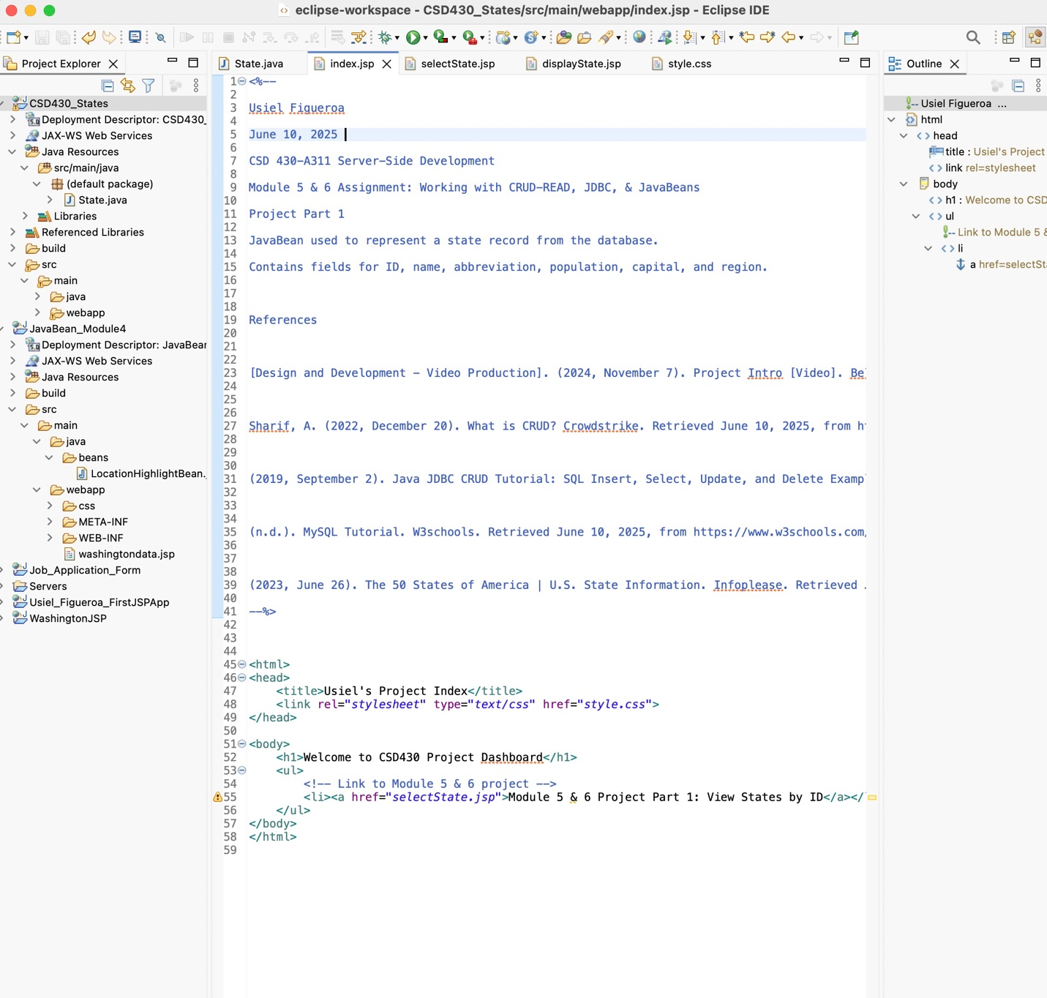

**References**

[Design and Development - Video Production]. (2024, November 7). Project Intro [Video]. Bellevue University. <https://bellevue.mediaspace.kaltura.com/media/Project+Intro/1_ciyf4naf>

Sharif, A. (2022, December 20). What is CRUD? Crowdstrike. Retrieved June 10, 2025, from https://www.crowdstrike.com/en-us/cybersecurity-101/observability/crud/

(2019, September 2). Java JDBC CRUD Tutorial: SQL Insert, Select, Update, and Delete Examples. Codejava. Retrieved June 10, 2025, from <https://www.codejava.net/java-se/jdbc/jdbc-tutorial-sql-insert-select-update-and-delete-examples>

(n.d.). MySQL Tutorial. W3schools. Retrieved June 10, 2025, from <https://www.w3schools.com/MySQL/default.asp>

(2023, June 26). The 50 States of America | U.S. State Information. Infoplease. Retrieved June 10, 2025, from <https://www.infoplease.com/us/states>